International Medicine 2019; 1(6):
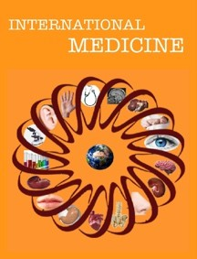
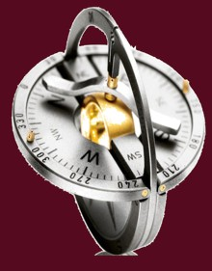

International Medicine

https://www.theinternationalmedicine.com

Case Report

Massive head and neck vascular malformation traversing multiple compartments: a case report
Jennifer F. Ha1,2, Carmen Chen1, David A. Zopf1
1Department of Pediatric Otorhinolaryngology Head and Neck Surgery, University of Michigan Health System, Ann Arbor, Michigan, USA
2Department of Pediatric Otorhinolaryngology Head and Neck Surgery, Perth Children’s Hospital, Nedlands, Western Australia, Australia

Received: 27 August 2019 / Accepted: 12 September 2019

Abstract

Capillary malformations (CM) are congenital low-flow vascular malformations that affect 0.3% of the general population. They are most commonly treated by pulsed-dye laser (PDL), which is most effective at a young age. The absence of treatment can lead to nodularity and hypertrophy. We report a case of a 6-year-old girl who has an extensive left facial and cervical CM that extends to the oral cavity and external auditory canal on the ipsilateral side. She had PDL as an infant that successfully lightened the color of her CM. She has been asymptomatic for at least four years and has since been treated conservatively. CM treatment options include conservative management, surgical excision and PDL treatments. In this paper, we report a case of successful conservative management of a massive head and neck CM. PDL for CM is most effective and provides optimal results when done at an early age. Conservative management is recommended for asymptomatic patients.

Keywords: conservative management, laryngopharynx, lasers, nasopharynx, oral cavity, vascular malformations

Introduction
Capillary malformations (CM) in the Mulliken and Glowacki classification are cutaneous low-flow vascular malformations that affect 0.3% of the general population [1-4]. Congenital CM is commonly confused with infantile hemangiomas, however, CM does not involute and may evolve through adulthood [1,4-8]. CM may vary in size, depth and location, but is most commonly found in the cervicofacial region. In rare instances, CM may extend to the lips and oral cavity [1]. CM appears as light pink macule lesions with irregular borders at birth. As the child grows older, these lesions will darken to a deep red-purple color and may become hypertrophic and/or nodular if left untreated [4,6]. Over 40% of CM is present along with the trigeminal nerve distribution [4]. CM has been found to be more strongly associated with the trigeminal nerve's ophthalmic branch (V1) distribution [4]. Those following the maxillary branch (V2) tend to have a deeper component, whilst the mandibular branch (V3) is often cutaneous and are unlikely to have intracranial extension [1,7]. In this paper, we present a case of an extensive CM that is managed conservatively with success.

Address for Correspondence: Jennifer F. Ha, Department of Pediatric Otolaryngology Head and Neck Surgery, Perth Children’s Hospital, 15 Hospital Avenue, Nedlands 6009, Western Australia, Australia. E-mail: drjennha@yahoo.com.au
DOI:
This is an Open Access article under the terms of the Creative Commons Attribution-NonCommercial 4.0 International License (https://creativecommons.org/licenses/by-nc/4.0/)

Case
A 6-year-old girl was referred to our pediatric otolaryngology department by her dermatologist for management of her extensive left face and neck CM with extensions into her oral cavity and external auditory canal. She had been followed up by her dermatologist for several years and did not require any treatment.
She had several pulsed-dye laser (PDL) treatment during infancy to lighten the color of the lesions. She had been completely asymptomatic since with no aerodigestive symptoms, seizure, bleeding or infections. There was a family history of vascular malformation on her paternal grandfather’s side.
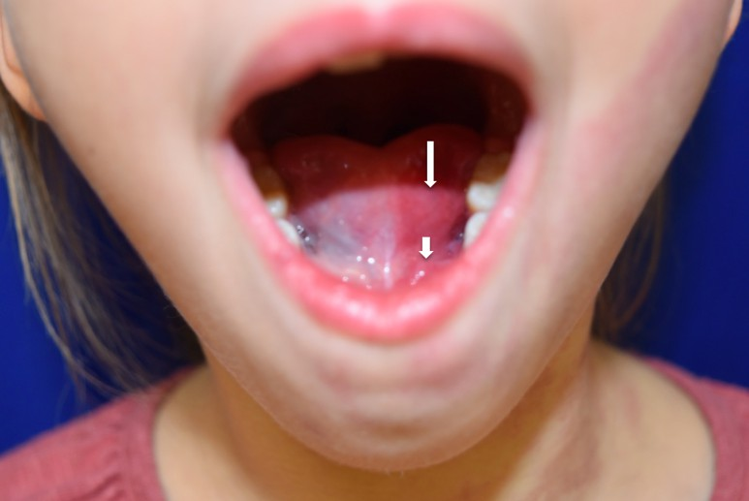

Figure 1. Capillary blushing of ventral surface of the left hemi tongue (long white arrow), with extension to the floor of mouth (short white arrow).

On examination she had a flat CM on her left lower cheek in the V3 distribution, extending down to her neck, crossing the midline of the mental and submental areas to involve the right cervical skin and the midline sternum. On otomicroscopy, the left external auditory canal showed mild capillary blushing medial to the bony-cartilaginous junction. The vascular malformation spared her left buccal surface but extended to the dorsal and ventral tongue, as well as the floor of mouth (Figure 1). It extended superiorly to the left soft palate from the uvula to the greater palatine foramen and retromolar trigone region.
The flexible nasoendoscopy revealed an extension up to the left side of her adenoidal pad (Figure 2), the nasal surface of the left hemipalate, inferiorly to the left lateral pharyngeal wall, the lingual surface of the epiglottis, the left aryepiglottic fold and left piriform fossa (Figure 3).
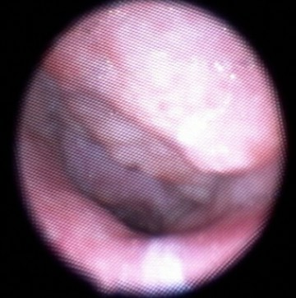

Figure 2. Extension up to the left side of the adenoidal pad.

Her dermatologist had offered her treatment of her lower face, neck and chest lesions as they have gradually progressed to become thicker and darker. He was also concerned about the risk of bleeding and infection. However, her family was reluctant to proceed with surgical interventions as she was asymptomatic and already had multiple surgeries for it.

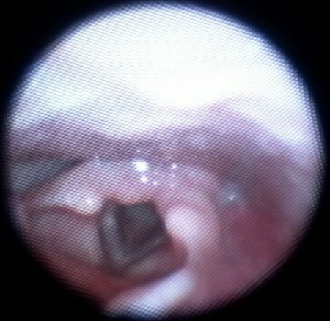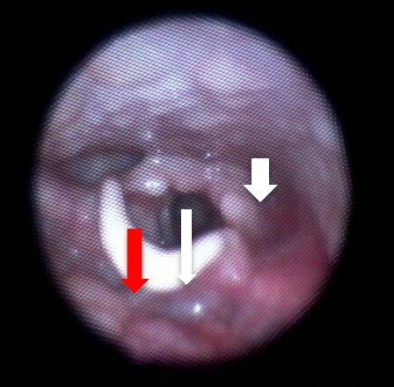

Figure 3. Capillary malformation involving the lateral pharyngeal wall (short white arrow), the lingual surface of the epiglottis (long red arrow), extending into the left aryepiglottic fold, left pyriform fossa (long white arrow) with a subtle subglottic blush.

The patient was scheduled to follow up in December 2016, however, she has since relocated to a different state. The extent of CM remained stable during her primary care follow up in July 2016. She may require surgery later.

Discussion
It is recommended that patients presenting with vascular malformations undergo imaging to determine the extent of the lesion prior to interventional procedures. Ultrasound (US) imaging is usually sufficient in evaluating superficial lesions, however, magnetic resonance imaging (MRI) is recommended if there is a concern for deeper components [7]. Contrast-enhanced MRI is also a valuable tool used to differentiate vascular malformations from hemangiomas [7].
Historically, surgery was a common form of treatment for vascular malformations. However, there has been a limited surgical success, especially for more diffuse CM [7]. Incomplete surgical excision may agitate certain subcategories of vascular malformations [2].
Currently, the gold standard treatment for CM is PDL therapy. It is preferable to other forms of laser treatments, such as Argon laser, as it minimizes scarring and dyspigmentation [4,6]. Laser treatments can help reduce the size and discoloration of the lesion by decreasing the magnitude and quantity of blood vessels. Studies have shown that maximal improvement in lightening the lesion and reducing its size is seen in the first five PDL treatment sessions [6]. In a study by Nguyen et al, there was a complete clearance of CM located on the central forehead and approximately one-third for those located on the lateral and central face within the first five PDL treatments. The most successful candidates were children less than one year old and with CM less than 20 cm2. Treatment of CM, while it is still in the macular stage, can help prevent hypertrophic and nodular evolution of the lesion in adulthood [4]. CO2 laser treatment is currently the most effective method to reduce nodular vascular malformations [4]. A consistent laser regimen is critical for optimal results and most effective when done at a young age.
Puig et al [7] adopted an algorithm by Yao et al [9] from the University of Tokyo to evaluate and determine the treatment plan for venous malformations. If the lesion is determined to be a low-flow malformation by MRI or US, then the treatment options are dependent on the patient's symptoms. If the patient is asymptomatic, then the algorithm recommends observation with close follow up. On the other hand, if the patient is symptomatic, then intervention is advised. Either way, the goal is to achieve a state of having or showing no symptoms and to continue with observation. Therefore, we elected to continue with conservative management and observation as our patient has low-flow CM that has been asymptomatic for at least four years. To the best of our knowledge, this is the most extensive CM involving multiple cervicofacial regions (external auditory canal, oral cavity, naso-, oro- and laryngopharynx and midline sternum) that was documented in detail to be treated conservatively. Many of the articles in the literature mentioned percentage improvement after treatment primarily with PDL. Aside from the size and the actual location of CM, the other limiting factor was the difference in the classification system. Not all articles uniformly used the Mulliken and Glowacki classification system.

Conclusion
CMs are congenital vascular malformations often presenting in the cervicofacial region, especially along with the distribution of the trigeminal nerve. Low-flow vascular malformations can be treated by a variety of methods, but most commonly by serial PDL treatments

at a young age to improve the appearance of the lesion or achieve complete resolution. Untreated CM can lead to nodularity. However, if the patient is asymptomatic, conservative management is recommended and the patient may be followed up with close observation.

Conflict of interest
The authors declare that they have no conflict of interest.

Funding
The authors declare no funding for this research.

References
- Garzon MC, Huang JT, Enjolras O, Frieden IJ. Vascular malformations: part I. J Am Acad Dermatol 2007;56:353-70.
- Kim YW. Proper selection of patients for percutaneous embolo-sclerotherapy in patients with congenital vascular malformations (CVMs). Eur J Vasc Endovasc Surg 2010;39:49-54.
- Lowe LH, Marchant TC, Rivard DC, Scherbel AJ. Vascular malformations: classification and terminology the radiologist needs to know. Semin Roentgenol 2012;47:106–117.
- Minkis K, Geronemus RG, Hale EK. Port wine stain progression: a potential consequence of delayed and inadequate treatment? Laser Surg Med 2009;41:423.
- Mulliken JB, Glowacki J. Hemangiomas and vascular malformations in infants and children: a classification based on endothelial characteristics. Plast Reconstr Surg 1982;69:412-20.
- Nguyen CM, Yohn JJ, Huff C, Weston WL, Morelli JG. Facial port wine stains in childhood: prediction of the rate of improvement as a function of the age of the patient, size and location of the port wine stain and the number of treatments with the pulsed dye (585 nm) laser. Br J Dermatol 1998;138:821-5.
- Puig S, Casati B, Staudenherz A, Paya K. Vascular low-flow malformations in children: current concepts for classification, diagnosis and therapy. Eur J Radiol 2005;53:35-45.
- Richter GT, Friedman AB. Hemangiomas and vascular malformations: current theory and management. Int J Pediatr 2012;2012:645678.
- Yao Y, Lomis NN, Scott SM, Yoon HC, Miller FJ. Percutaneous sclerotherapy for congenital venous malformations in the extremities. Orthopedics 2001;24:45-51.

